**Communicate with shared memory using the Win32 AP**

**These problems design to share memory location between producer and consumer, where the producer process will generate the Catalan sequence and write it to a shared memory object and the consumer process will then read and output the sequence from shared memory.**

**Flow diagram:**

**Process1 = producer**

**Process2 = consumer**

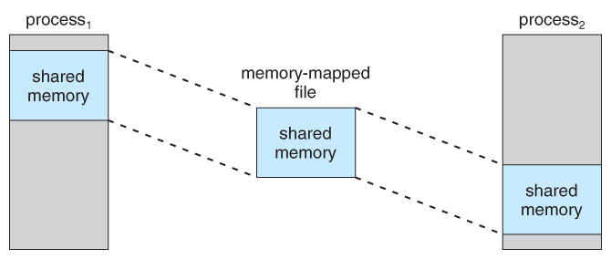

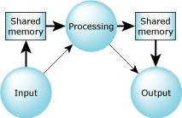

**Functions description:**

**Producer:**

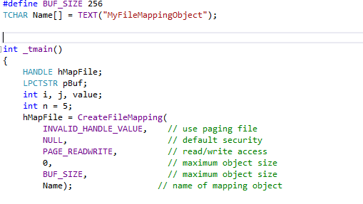

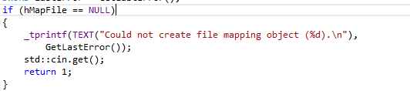

**Create file mapping location to allow the information to be shared and make sure it open correctly. Otherwise exit the program.**

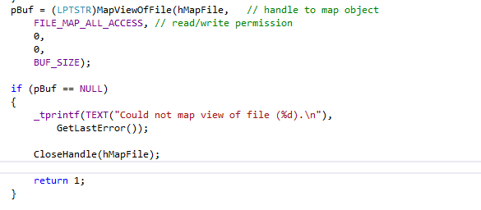

**To check if we can read and write on the file location and have full permission to make changes.**

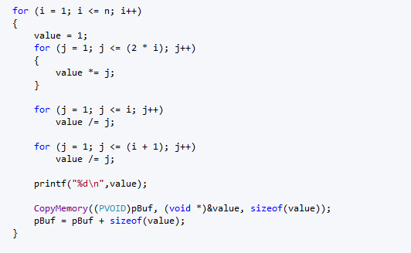

**Here, we used C:\Users\Nicole\Desktop\test\0b5e8fc00437b07163e01d2923b749af.png Catalan formula to generate the result from the first five numbers where n = 1, 2, 3, 4, 5. We save the result on a specific memory location so we can retrieve the result.**

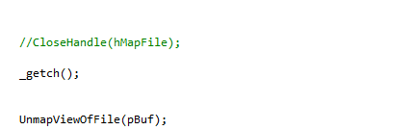

**Note: I made close handler as comment because if you close the handler you will lose the data that was save on the location. Consumer will close the handler**

**Consumer:**

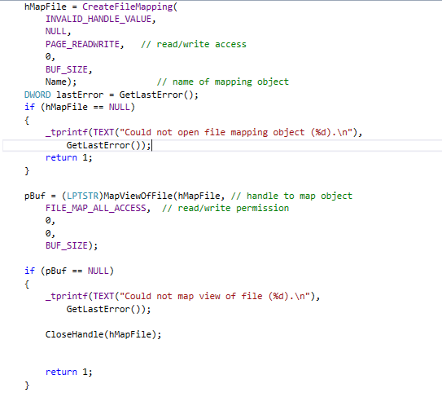

**This part same as producer**

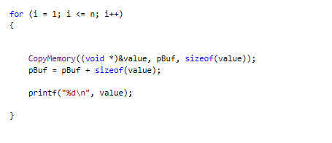

**Loop to generate result and print it on system console**

**Compiled and executed:**

**You need to do same process for producer first then do it for consumer**

* **Open “program4 – Alajaj” file. For producer open “producer- Alajaj” file or for consumer open “consumer- Alajaj”**
* **Open code file (producer- Alajaj.sln) or (consumer- Alajaj.sln) “this will open Visual studio 2013”**
* **To compile the code :**
  + **From top Manu bar : BUILD >> rebuild solution**
* **Now you will see this which mean to compiled correctly**
* 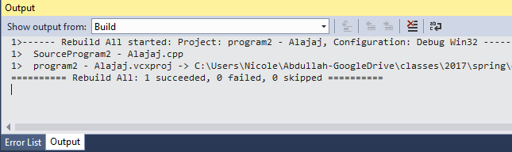
* **To execute the code : DEBUG >> start debugging or press F5**

**Note:**

1. **Do not close producer console before you see consumer console. If you do that the result will be all zero.**
2. **When you are done, close producer console then click enter on consumer console so it will close.**

**Result:**

**Producer:**

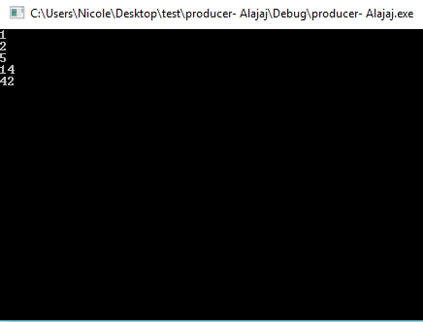

**Consumer:**

